Project Planning Phase
Project Planning Template (Product Backlog, Sprint Planning, Stories, Story Points)
Date | 14 October 2026
Team ID | —————————————
Project Name | Car Rental Request Automation in ServiceNow Using Service Catalog and Workflows
Maximum Marks | 5 Marks
Product Backlog, Sprint Schedule and Estimation (4 Marks)
Below are the product backlog and sprint schedule for the Car Rental Request Automation project: 26 user stories across 6 epics, estimated in story points of 1, 2, 3 and 5.
Sprint | Functional requirement (epic) | User story no. | User story / task | Story points | Priority | Team member
Sprint-1 | Requirement analysis & planning | USN-1 | As a project owner, I can set out the business goals for automating car rental requests. | 2 | High | Vamsi Bhavirisetti
Sprint-1 |  | USN-2 | As a project owner, I can define the functional scope: catalog item, form, approvals, tasks, notifications and SLA. | 2 | High | Vamsi Bhavirisetti
Sprint-1 |  | USN-3 | As a project owner, I can identify the stakeholders (requesters, managers, transport team, admins) and what each needs. | 1 | Medium | Vamsi Bhavirisetti
Sprint-1 |  | USN-4 | As a project owner, I can draw up an execution roadmap with milestones for every phase. | 1 | Medium | Vamsi Bhavirisetti
Sprint-1 | Backend development & configuration (data architecture) | USN-5 | As an admin, I can create an Update Set that tracks every configuration change for deployment. | 1 | High | Vamsi Bhavirisetti
Sprint-1 |  | USN-6 | As an admin, I can design the data architecture covering REQ, RITM, SCTASK, approvals and the Car Inventory table. | 3 | High | Vamsi Bhavirisetti
Sprint-1 |  | USN-7 | As an employee, I can use a “Car Rental Request” catalog item with variables for requested date, pick-up location, drop location, duration, car type and reason. | 3 | High | Vamsi Bhavirisetti
Sprint-1 |  | USN-8 | As an admin, I can set up Business Rules that assign tasks automatically and update the request status after approvals. | 3 | High | Vamsi Bhavirisetti
Sprint-2 |  | USN-9 | As a manager, I get an approval request from the flow (primary manager approval) whenever a car rental request is submitted. | 3 | High | Vamsi Bhavirisetti
Sprint-2 |  | USN-10 | As an approver, I can give the secondary car request approval once the flow has checked car availability. | 3 | High | Vamsi Bhavirisetti
Sprint-2 |  | USN-11 | As a transport team member, I get an assignment task (SCTASK) for each approved request. | 2 | High | Vamsi Bhavirisetti
Sprint-2 |  | USN-12 | As a user, I get email notifications at every stage: submitted, approved, assigned and closed. | 2 | Medium | Vamsi Bhavirisetti
Sprint-2 |  | USN-13 | As an admin, I can attach the workflow to the catalog item so every request follows the defined process. | 2 | High | Vamsi Bhavirisetti
Sprint-2 | UI/UX development & customization | USN-14 | As an employee, I can submit requests through a clean, easy-to-use catalog form. | 2 | Medium | Vamsi Bhavirisetti
Sprint-2 |  | USN-15 | As a user, I can follow a clear path from the catalog item to the REQ, RITM and approval status. | 2 | Medium | Vamsi Bhavirisetti
Sprint-2 |  | USN-16 | As a user, I can read tooltips and help text on form fields to fill them in easily. | 1 | Low | Vamsi Bhavirisetti
Sprint-2 |  | USN-17 | As an employee, I get mandatory-field checks and auto-fill from client scripts while completing the form. | 3 | High | Vamsi Bhavirisetti
Sprint-3 | Data migration, testing & security | USN-18 | As an admin, I can move existing car rental data into the new ServiceNow structure. | 3 | Medium | Vamsi Bhavirisetti
Sprint-3 |  | USN-19 | As an admin, I can enforce role-based access so only the right roles can view or approve requests. | 3 | High | Vamsi Bhavirisetti
Sprint-3 |  | USN-20 | As an admin, I can enforce data integrity so that no request moves ahead without the required approvals. | 3 | High | Vamsi Bhavirisetti
Sprint-3 |  | USN-21 | As a tester, I can run QA tests covering submission, approval routing, task creation and fulfillment. | 5 | High | Vamsi Bhavirisetti
Sprint-3 |  | USN-22 | As an admin, I can troubleshoot with flow execution logs and confirm that email notifications work. | 3 | Medium | Vamsi Bhavirisetti
Sprint-4 | Deployment, documentation & final presentation | USN-23 | As an admin, I can complete the Update Set, retrieve it on the target instance, preview it and commit it. | 3 | High | Vamsi Bhavirisetti
Sprint-4 |  | USN-24 | As a tester, I can verify the complete request flow on the target instance after deployment. | 2 | High | Vamsi Bhavirisetti
Sprint-4 |  | USN-25 | As a stakeholder, I can read the technical and user documentation for the solution. | 3 | Medium | Vamsi Bhavirisetti
Sprint-4 | Project conclusion | USN-26 | As a stakeholder, I can watch a final presentation and conclusion showing the working system. | 2 | Medium | Vamsi Bhavirisetti
Project Tracker, Velocity and Burndown Chart (4 Marks)
Sprint | Total story points | Duration | Sprint start date | Sprint end date (planned) | Story points completed (by planned end date) | Sprint release date (actual)
Sprint-1 | 16 | 6 days | 26 Oct 2026 | 31 Oct 2026
Sprint-2 | 20 | 6 days | 02 Nov 2026 | 07 Nov 2026
Sprint-3 | 17 | 6 days | 09 Nov 2026 | 14 Nov 2026
Sprint-4 | 10 | 6 days | 16 Nov 2026 | 21 Nov 2026
Velocity
The project runs for 4 sprints of 6 days each. Total story points = 16 + 20 + 17 + 10 = 63. Velocity = total story points ÷ number of sprints = 63 ÷ 4 = 15.75, roughly 16 story points per sprint. Average velocity per day = 16 ÷ 6 ≈ 2.67 story points per day.
Burndown Chart
A burndown chart shows the work remaining against time. The chart below gives the planned burndown of the 26 stories (63 story points) across the four sprints.
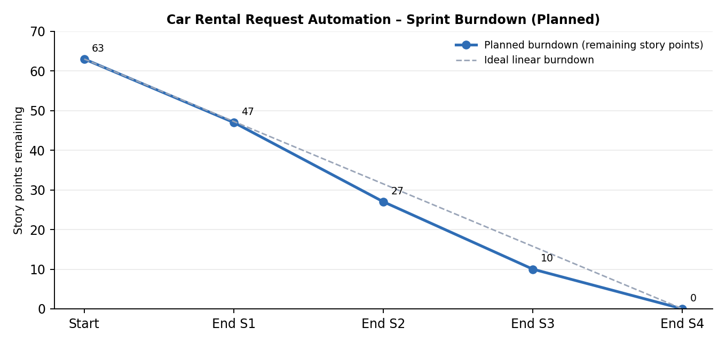
https://www.visual-paradigm.com/scrum/scrum-burndown-chart/
https://www.atlassian.com/agile/tutorials/burndown-charts
References
https://www.atlassian.com/agile/project-management
https://www.atlassian.com/agile/tutorials/how-to-do-scrum-with-jira-software
https://www.atlassian.com/agile/tutorials/epics
https://www.atlassian.com/agile/tutorials/sprints
https://www.atlassian.com/agile/project-management/estimation

